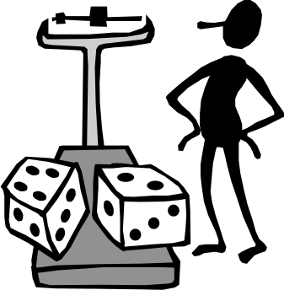
Chapter 1: Exploring Data

Key Vocabulary:

- individuals
- variables
- categorical variable
- quantitative variable
- distribution
- range
- spread
- frequency
- outlier
- center
- shape
- skewed left
- skewed right
- symmetric
- dot plot
- histogram
- stemplot
- split stems
- back-to-back stemplot
- time plot
- mean
- Σ
- nonresistant
- median
- resistant
- quartiles
- Q₁, Q₃

- IQR
- five-number summary
- minimum
- maximum
- boxplot
- modified boxplot
- standard deviation
- variance

Calculator Skills:

- round( )
- sortA( )
- sum
- mean
- 1-Var Stats
- Float
- ENTRY
- ANS
- ZoomStat
- TRACE
- WINDOW

  - Displaying Distributions with Graphs
- In statistics, what is meant by individuals?
- In statistics, what is meant by a variable?
- What is meant by exploratory data analysis?
- What is the difference between a categorical variable and a quantitative variable?
- When is it useful to use a bar chart?
- When is it useful to use a pie chart?
- What is meant by a distribution?
- Define range:
- When is it better to use a histogram rather than a dotplot?
- What is meant by frequency in a histogram?
- When setting a window for constructing a histogram on the TI-83:
  - What is the significance of Xscl?
  - How do you choose the values of Xmin and Xmax?
  - What is the significance of Ymax?
- Define outlier.
- If a distribution is symmetric, what does its histogram look like?
- If a distribution is skewed right, what does its histogram look like?
- If a distribution is skewed left, what does its histogram look like?
- How is the stemplot of a distribution related to its histogram?
- When is it advantageous to split stems on a stemplot?
- What is the purpose of a back-to-back stemplot?
- When is it useful to construct a time plot?
  - Describing Distributions with Numbers
- In statistics, what is the most common measurement of center?
- Explain how to calculate the mean,.
- Explain how to calculate the median, M.
- Explain why the median is resistant to extreme observations, but the median is nonresistant.
- In statistics, what is meant by spread?
- Explain how to calculate Q₁ and Q₃.
- What is the five-number summary?
- What does standard deviation measure?
- What is the relationship between variance and standard deviation?
- When does standard deviation equal zero?
- Is standard deviation resistant or nonresistant to extreme observations? Explain.

